Common Rate Limiting Strategies - Token Bucket

🚦 What is Token Bucket
# Source: AI Source: Provided by: [Data Path: Persons Table -> ID Column: 1, Name_En Column: Motasem Essam] -> From: [ChatGPT] on [1/19/2026]
Token Bucket is a flexible rate limiting strategy that allows bursts of traffic while still enforcing an overall rate limit over time.
👉 Think of it as a bucket filled with tokens. Each request needs a token to proceed.

🔑 How It Works
# Source: AI Source: Provided by: [Data Path: Persons Table -> ID Column: 1, Name_En Column: Motasem Essam] -> From: [ChatGPT] on [1/19/2026]
- The server maintains a bucket of tokens
- Tokens are added (refilled) at a fixed rate
- Each incoming request consumes 1 token
- If no tokens are available → ❌ request is rejected

🧱 Example
# Source: AI Source: Provided by: [Data Path: Persons Table -> ID Column: 1, Name_En Column: Motasem Essam] -> From: [ChatGPT] on [1/19/2026]
Rule
Bucket size = 5 tokens
Refill rate = 1 token every 10 seconds

Scenario 1️⃣ – Normal Usage
# Source: AI Source: Provided by: [Data Path: Persons Table -> ID Column: 1, Name_En Column: Motasem Essam] -> From: [ChatGPT] on [1/19/2026]
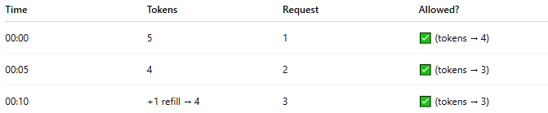
Time | Tokens | Request | Allowed?
00:00 | 5 | 1 | ✅ (tokens → 4)
00:05 | 4 | 2 | ✅ (tokens → 3)
00:10 | +1 refill → 4 | 3 | ✅ (tokens → 3)
👉 Smooth and controlled

Scenario 2️⃣ – Burst Allowed
# Source: AI Source: Provided by: [Data Path: Persons Table -> ID Column: 1, Name_En Column: Motasem Essam] -> From: [ChatGPT] on [1/19/2026]
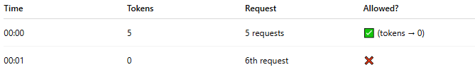
Time | Tokens | Request | Allowed?
00:00 | 5 | 5 requests | ✅ (tokens → 0)
00:01 | 0 | 6th request | ❌
👉 You can send multiple requests at once (burst)
👉 But only up to bucket capacity

Scenario 3️⃣ – Recovery After Burst
# Source: AI Source: Provided by: [Data Path: Persons Table -> ID Column: 1, Name_En Column: Motasem Essam] -> From: [ChatGPT] on [1/19/2026]
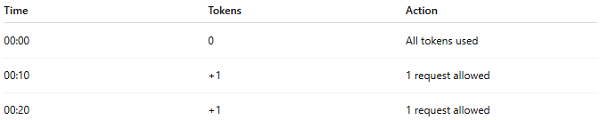
Time | Tokens | Action
00:00 | 0 | All tokens used
00:10 | +1 | 1 request allowed
00:20 | +1 | 1 request allowed
👉 Tokens slowly refill → system recovers

🔄 Why Token Bucket Prevents Problems
# Source: AI Source: Provided by: [Data Path: Persons Table -> ID Column: 1, Name_En Column: Motasem Essam] -> From: [ChatGPT] on [1/19/2026]
- Unlike Fixed Window ❌ → no sudden reset
- Unlike Sliding Window ⚠️ → allows controlled bursts
- Ensures:
  - Short bursts ✅
  - Long-term rate control ✅

🧩 Simple Implementation Idea
# Source: AI Source: Provided by: [Data Path: Persons Table -> ID Column: 1, Name_En Column: Motasem Essam] -> From: [ChatGPT] on [1/19/2026]
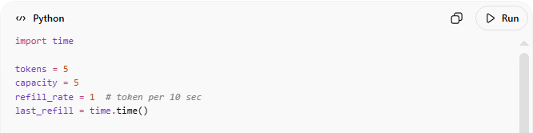
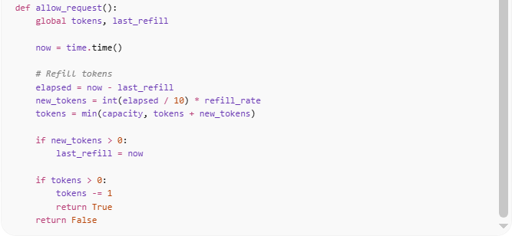

import time

tokens = 5
capacity = 5
refill_rate = 1 # token per 10 sec
last_refill = time.time()

def allow_request():
global tokens, last_refill

now = time.time()

# Refill tokens
elapsed = now - last_refill
new_tokens = int(elapsed / 10) * refill_rate
tokens = min(capacity, tokens + new_tokens)

if new_tokens > 0:
last_refill = now

if tokens > 0:
tokens -= 1
return True
return False

Code Description

Part 1
# Source: AI Source: Provided by: [Data Path: Persons Table -> ID Column: 1, Name_En Column: Motasem Essam] -> From: [ChatGPT] on [1/19/2026]
Variables
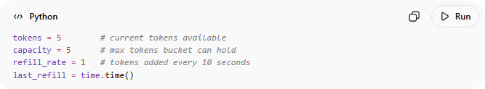
tokens = 5 # current tokens available
capacity = 5 # max tokens bucket can hold
refill_rate = 1 # tokens added every 10 seconds
last_refill = time.time()
Idea
- Think of a bucket of tokens
- Each request needs 1 token
- If token exists → ✅ allowed
- If no token → ❌ rejected
- Tokens are refilled over time

Part 2
# Source: AI Source: Provided by: [Data Path: Persons Table -> ID Column: 1, Name_En Column: Motasem Essam] -> From: [ChatGPT] on [1/19/2026]
⚙️ Step-by-Step Logic
⏱️ Calculate time passed
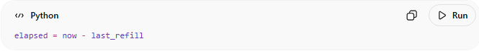
elapsed = now - last_refill

Part 3
# Source: AI Source: Provided by: [Data Path: Persons Table -> ID Column: 1, Name_En Column: Motasem Essam] -> From: [ChatGPT] on [1/19/2026]
🔄 Refill tokens
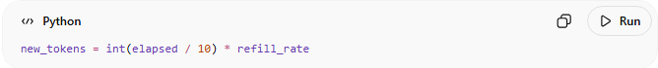
new_tokens = int(elapsed / 10) * refill_rate
- Every 10 seconds → 1 token added
- Example:
  - 25 sec → int(25/10) = 2 tokens

Part 4
# Source: AI Source: Provided by: [Data Path: Persons Table -> ID Column: 1, Name_En Column: Motasem Essam] -> From: [ChatGPT] on [1/19/2026]
Update bucket
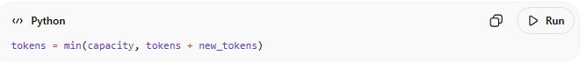
tokens = min(capacity, tokens + new_tokens)
- Never exceed capacity (5)

Part 5
# Source: AI Source: Provided by: [Data Path: Persons Table -> ID Column: 1, Name_En Column: Motasem Essam] -> From: [ChatGPT] on [1/19/2026]
🎯 Allow or reject
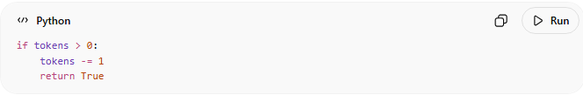
if tokens > 0:
tokens -= 1
return True

Full Scenario Table (All Cases)

Initial State
# Source: AI Source: Provided by: [Data Path: Persons Table -> ID Column: 1, Name_En Column: Motasem Essam] -> From: [ChatGPT] on [1/19/2026]
- tokens = 5 (full bucket)

Scenario 1: Burst Requests (Immediate)
# Source: AI Source: Provided by: [Data Path: Persons Table -> ID Column: 1, Name_En Column: Motasem Essam] -> From: [ChatGPT] on [1/19/2026]
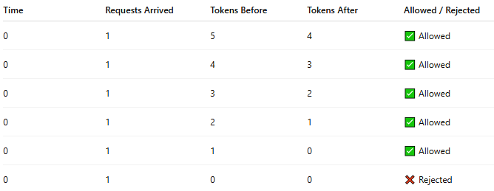
Time | Requests Arrived | Tokens Before | Tokens After | Allowed / Rejected
0 | 1 | 5 | 4 | ✅ Allowed
0 | 1 | 4 | 3 | ✅ Allowed
0 | 1 | 3 | 2 | ✅ Allowed
0 | 1 | 2 | 1 | ✅ Allowed
0 | 1 | 1 | 0 | ✅ Allowed
0 | 1 | 0 | 0 | ❌ Rejected
✅ Result:
- Allows burst of 5 requests instantly
- 6th request is rejected

Scenario 2: No Requests → Refill Happens
# Source: AI Source: Provided by: [Data Path: Persons Table -> ID Column: 1, Name_En Column: Motasem Essam] -> From: [ChatGPT] on [1/19/2026]
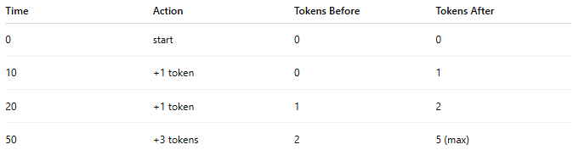
Time | Action | Tokens Before | Tokens After
0 | start | 0 | 0
10 | +1 token | 0 | 1
20 | +1 token | 1 | 2
50 | +3 tokens | 2 | 5 (max)
✅ Tokens refill over time until capacity

Scenario 3: Mixed Traffic
# Source: AI Source: Provided by: [Data Path: Persons Table -> ID Column: 1, Name_En Column: Motasem Essam] -> From: [ChatGPT] on [1/19/2026]
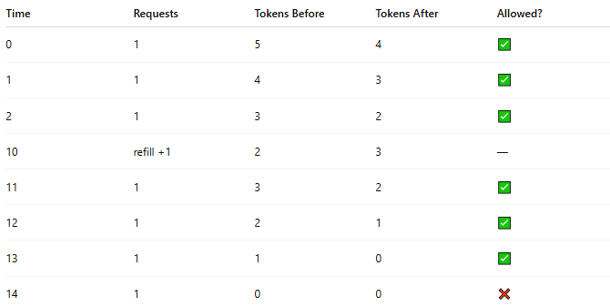
Time | Requests | Tokens Before | Tokens After | Allowed?
0 | 1 | 5 | 4 | ✅
1 | 1 | 4 | 3 | ✅
2 | 1 | 3 | 2 | ✅
10 | refill +1 | 2 | 3 | —
11 | 1 | 3 | 2 | ✅
12 | 1 | 2 | 1 | ✅
13 | 1 | 1 | 0 | ✅
14 | 1 | 0 | 0 | ❌

Scenario 4: Max-1 then Multiple Requests
# Source: AI Source: Provided by: [Data Path: Persons Table -> ID Column: 1, Name_En Column: Motasem Essam] -> From: [ChatGPT] on [1/19/2026]
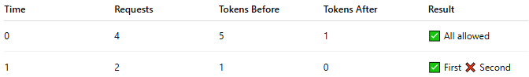
Time | Requests | Tokens Before | Tokens After | Result
0 | 4 | 5 | 1 | ✅ All allowed
1 | 2 | 1 | 0 | ✅ First ❌ Second

🚀 How This Prevents Burst
# Source: AI Source: Provided by: [Data Path: Persons Table -> ID Column: 1, Name_En Column: Motasem Essam] -> From: [ChatGPT] on [1/19/2026]
✅ Key Idea:
- You can only send as many requests as you have tokens
✔️ Controls Burst:
- Max burst = capacity (5)
- After that → ❌ rejected
✔️ Smooth Rate:
- Refill = 1 request every 10 seconds
🔥 Simple Understanding
- Bucket full → can handle burst traffic
- Bucket empty → reject requests
- Over time → slowly recovers
🧠 Final Insight
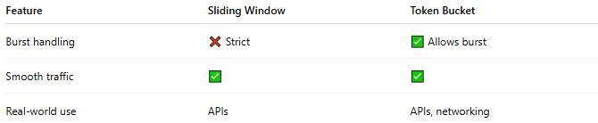
Feature | Sliding Window | Token Bucket
Burst handling | ❌ Strict | ✅ Allows burst
Smooth traffic | ✅ | ✅
Real-world use | APIs | APIs, networking

✅ Advantages
# Source: AI Source: Provided by: [Data Path: Persons Table -> ID Column: 1, Name_En Column: Motasem Essam] -> From: [ChatGPT] on [1/19/2026]
- Allows controlled bursts
- Smooth traffic over time
- Widely used in real systems (APIs, networking)

❌ Disadvantages
# Source: AI Source: Provided by: [Data Path: Persons Table -> ID Column: 1, Name_En Column: Motasem Essam] -> From: [ChatGPT] on [1/19/2026]
- Slightly more complex than Fixed Window
- Requires tracking tokens and time

🧾 Summary
# Source: AI Source: Provided by: [Data Path: Persons Table -> ID Column: 1, Name_En Column: Motasem Essam] -> From: [ChatGPT] on [1/19/2026]
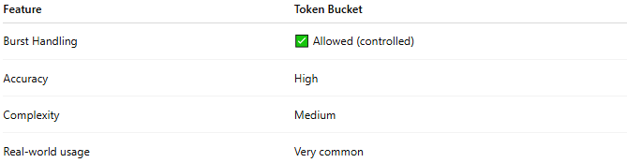
Feature | Token Bucket
Burst Handling | ✅ Allowed (controlled)
Accuracy | High
Complexity | Medium
Real-world usage | Very common
Token Bucket = burst-friendly + rate-controlled
You can send many requests at once only if you have tokens, and tokens refill gradually over time.

